# Transfer Learning for Custom Datasets in the Small-Data Regime

Table of Contents

Introduction 3

Study Background 3

Implementation 3

Milestone 1: Preparing environment 4

Milestone 2: Data retrieval 4

Milestone 3 4

Milestone 4 5

Conclusion 7

References 8

# Introduction

Machine learning has been introduced as a major step that provides computer systems the ability to mimic the decision making process of a human being. The machine learning algorithms are primarily divided into “supervised” and “unsupervised learning”. In this assignment the main focus is on unsupervised learning. Labeling of data becomes an important step in the “supervised learning” implementation. Generally data are labeled into categories however in this assignment the process of data annotations is signified. The assignment consists of five milestones that are required to be incorporated. CVAT is installed in the local system which is basically an annotation tool for computer vision. The implementation of data scraping is done using “beautiful soup”. The importance of “DEXTER cutter” is showcased for annotation on the image dataset. Semantic segmentation is performed next using neural network classifications. The practical implementation is done by installing the CVAT tool and performing image segmentation using python in the Jupyter Notebook platform.

# Study Background

Image annotations are among the most essential parts of different “computer vision algorithms”. This is because they serve as the training data which is taken as the input for the supervised learning. The increase in the quality of the annotations allows the model to view the world and develop highly accurate insights using the application. The annotations are generally done to identify the boundaries and objects and perform image segmentation for meaning and instance. Image segmentation requires a large amount of data to validate, train and test the “machine learning model” so that the desired outcome can be achieved (Berg *et al*. 2019). In information systems image annotations are essential as it allows the machine to initialize differentiation among the input images. The annotations help in delivering results that are accurate and elements can also be identified. This identification helps the machines to train computer speech and vision, and also for the recognition of models (Khan *et al*. 2018). There are different forms of image annotations such as “boundary boxes”, “polygonal segmentation”, “semantic segmentation”, and many more. Detection of objects can be preceded by the COCO format such that it is primarily stored in a JSON file. There are various tools for image annotation like “VGG image annotator” which is implemented in this assignment.

# Implementation

The different approaches to the completion of the milestones are presented in this section.

## Milestone 1: Preparing environment

The CVAT tool is installed in the local computer system with different instructions. CVAT stands for “Computer Vision Annotation Tool” which is used for the labeling of data for computer vision. Different tasks such as image classification, object tracking and detection are performed using CVAT.

## Milestone 2: Data retrieval

The acquisition of data is an essential step as it provides the data that is going to be used for various analyses. In this assignment the data is obtained from a website using python scraping tool “BeautifulSoup”. This tool is basically a library that is used for scraping HTML files from online. Various images of rooms are scraped using this tool.

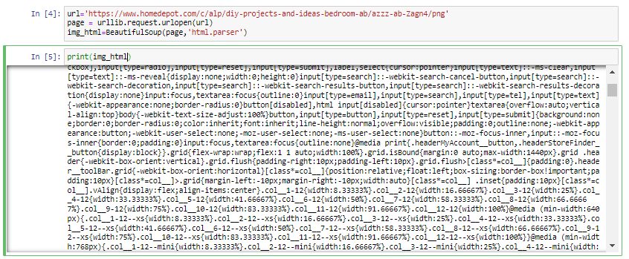

**Figure 1: Retrieving data using “BeautifulSoup”**

(Source: Acquired from Jupyter Notebook)

In the above figure the code to retrieve the data with the help of “BeautifulSoup” library is showcased.

## Milestone 3

The images can be uploaded into the CVAT instance so that the object categories can be annotated. The “DEXTR cutter” can be used so that all the object categories are annotated properly. The DEXTR stands for “Deep Extreme Cut” which is a basic user interface based on matplotlib (Christopoulou, 2022). The object segmentation is present within the “DEXTR” from extreme four points (Isensee*et al*. 2021). These points are “left-most”, “top”, “right-most”, and the “bottom” pixels. These extreme points that are annotated are used as a form of guiding signals that are input into the network.

## Milestone 4

The semantic segmentation can be described as the process of pixel association with a label of class. Various objects are treated into a similar category when the semantic segmentation is performed. Semantic segmentation is very crucial as it is used for making improvements in the existing algorithms that are related to various image analysis (Buslaev *et al*. 2020). These analyses include “human-computer interactions” and multiple other applications. In the applications the access to the segmentations helps the researchers to initiate a problem on the semantic level.

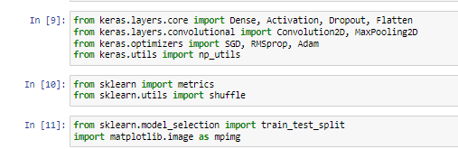

**Figure 2: Importing libraries**

(Source: Acquired from Jupyter Notebook)

The libraries are imported as shown in figure 2 so that the segregation of the images into their respective classes can be achieved.

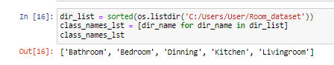

**Figure 3: Different rooms**

(Source: Acquired from Jupyter Notebook)

The rooms are categorized into five major classes.

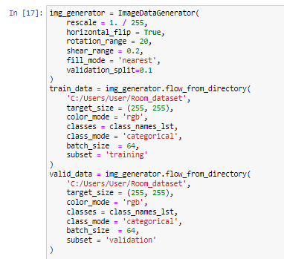

**Figure 4: Image generator**

(Source: Acquired from Jupyter Notebook)

The image generator is used to split the entire dataset into training and validation.



**Figure 5: Data splitting**

(Source: Acquired from Jupyter Notebook)

The image data is splitted into appropriate training and testing where 4728 images are allotted to the training and the rest 522 images are given to testing.

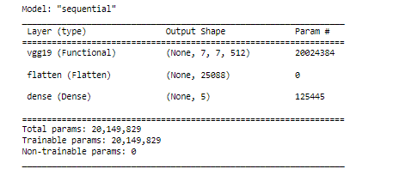

**Figure 6: Model summary**

(Source: Acquired from Jupyter Notebook)

The summary of the model is shown above. It is seen that the layer type is flatten and dense. The output shape is selected as “none, 5” as there are five main classes present in the image dataset.

# Conclusion

It can be concluded from the above assignment that annotation of images is a very important step that helps the model to identify the different image categories. The annotation can be implemented to other forms of data types so that the machines are able to identify the type of data that they are dealing with. Incorporation of Jupyter Notebook is successfully achieved within which python programming is used to perform data retrieval and segmentation applications. The process of web scraping is also included so that the html format of the images from the selected website is appropriately provided. The neural network model is implemented so that the images can be segregated into their respective classes. The coding approaches are submitted into github as well. It is finally concluded that the process of image annotation has several approaches and its significance is also understood throughout the course of the assignment.

# References

Berg, S., Kutra, D., Kroeger, T., Straehle, C.N., Kausler, B.X., Haubold, C., Schiegg, M., Ales, J., Beier, T., Rudy, M. and Eren, K., 2019. Ilastik: interactive machine learning for (bio) image analysis. *Nature methods*, *16*(12), pp.1226-1232.

Buslaev, A., Iglovikov, V.I., Khvedchenya, E., Parinov, A., Druzhinin, M. and Kalinin, A.A., 2020. Albumentations: fast and flexible image augmentations. *Information*, *11*(2), p.125.

Christopoulou, S.C., 2022. Machine Learning Tools and Platforms in Clinical Trial Outputs to Support Evidence-Based Health Informatics: A Rapid Review of the Literature. *BioMedInformatics*, *2*(3), pp.511-527.

Isensee, F., Jaeger, P.F., Kohl, S.A., Petersen, J. and Maier-Hein, K.H., 2021. nnU-Net: a self-configuring method for deep learning-based biomedical image segmentation. *Nature methods*, *18*(2), pp.203-211.

Khan, M.J., Khan, H.S., Yousaf, A., Khurshid, K. and Abbas, A., 2018. Modern trends in hyperspectral image analysis: A review. *Ieee Access*, *6*, pp.14118-14129.